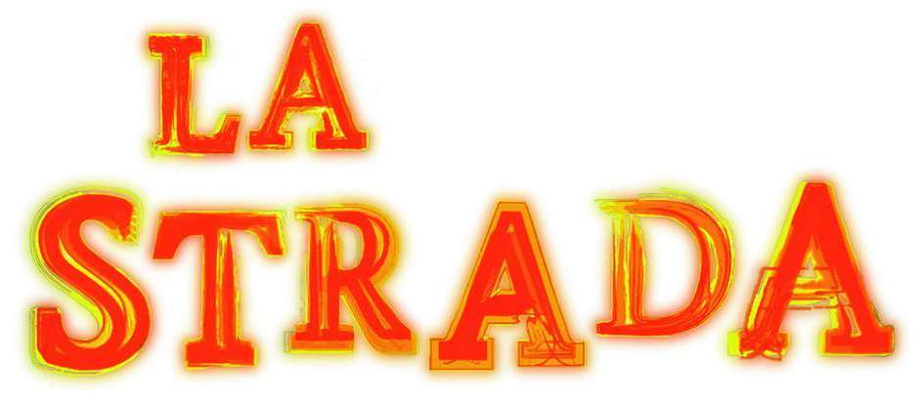LA STRADA – international street circus festival
August 12-15 in Bremen

Figures and Facts

- 16th anniversary in 2010
- Since 1994 304 theatre companies from 30 different countries
- ~ 150.000 spectators
- ~ 20 professional event manager and technicians
- ~ 100 volunteers
- Yearly about 10-12 premieres
- ~ 150 shows presented in public space
- Two gala-nights a the local theatre
- Two open-air shows with an entrance fee
- Welcome reception at the town hall
- Street theatre conference the two days before the festivals starts

The genre in general is hardly accepted by the cultural funding institutions as a special theatre art form. Mainly because street theatre and street circus don’t match into the classic theatre funding system (no director, no text, no literature based approach, no definded ensemble, no institution behalve the groupe). Therefore street theatre and street circus in Germany is mainly funded by City Marketing Institutions. Some cities and regions realized who powerful the pictures are, which are created by street theatre and street circus.

Catchwords for the powerpoint:
Street theatre and street circus is hardly accepted as a special art form
Don’t match in the German funding system
Festivals are mainly funded be the City Marketing
Street theatre creates powerful positive pictures

Nevertheless street theatre and – circus as very popular art form attracts millions of people in Germany. This is on one hand caused by the mainly admission free performances shown in public space, on the other hand by the fact that street theatre and street circus seems to be a very adequate theatre form for modern times.

Catchwords for the powerpoint:
Street theatre and street circus attracs millions of people
Mainly admission free
Adequate theatre from for modern times

The difficult funding system is one reason of the difficult production conditions.
We have no centre for production in Germany. It is very hard to get a funding for a street theatre production. For Solo and Duos almost impossible, a bit easier for bigger companies, which are in general hard to finance.
There is no support for travel costs at all.

Catchwords for the powerpoint:
No production centre in Germany
Almost no funding for the production side
No funding for travel costs

The terms of production have of cause in influence on the quality of the productions. And the quality of shows also have an influence on the funding system, as if there are few high quality production to be shown the acceptance of street theatre as an special art form is hard to get.

Catchwords for the powerpoint:
Quality of performances

LA STRADA as cooperation partner for OPEN STREET

LA STRADA is very happy to be part of the project. Specially because we know Roberto and Alessio quiet a while and admire them for their great work for street art, theatre and circus. Thank you for setting up this project.

The second partner in the project are Nathalie and Jean-Felix, which we adore for their positive way thinking, which makes things possible, their great work for street circus and their experience in organisation and negotiations.

So we are really proud to be part of the project and can’t wait to intensify the cooperation.

LA STRADA will support the Italian Partner in their actions, help to spread the information of OPEN STREET and communicate the idea with all its partners.
In this context LA STRADA will already use the street theatre conference in 2010 to let the invited professionals know about OPEN STREET and to invite them for next years forum. LA STRADA will stay in close contact to the partners in Italy and Belgium to develop a concept to open up the street to street art where it is needed and to may be define rules reclaimable for more than the three cooperating countries.
Moreover LA STRADA will invite some of the performances shown at the Italian Showcase and organize a Forum at LA STRADA Bremen 2011.

Catchwords for the powerpoint:
Communicate the idea
Support the Italian partner in all their action
Use the conference in 2010 to spread the information
Develop a concept to open up the street for street art
Define rules
Organize a Forum in Bremen in 2011
Invite performance from the network of OPEN STREET

