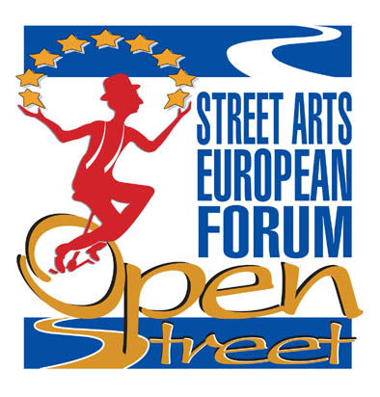
OPEN INTERNATIONAL MEETING
Programme

Building Europe on Street and on Ring
20th June – Pennabilli (RN)

11:00 hrs. Activites start
Welcome of City Commissioner of Pennabilli Mrs. Giovanna Longhi

11:05 hrs.
Welcome of Art director of Artistiinpiazza Festival, Enrico Partisani

11:10 hrs.
Luigi Russo, President of Federazione Nazionale Arte di Strada (IT)

11:20 hrs.
Alessio Michelotti, coordinator for OPEN Project

11:30 hrs.
Jean-Felix Tirtiaux, Director of “Namur en Mai”, Open Forum Belgium

11:40 hrs.
Laurent Bourdereau, Conseil Général de l'Essonne (FR), OPEN Partner

11:50 hrs.
Aleksandar Caric "Uličnih Svirača Festival" Novi Sad (SR), OPEN Partner

12:00 hrs.
Sylvie Pradayrol, Fédération National des Arts de la Rue, Paris (FR)

12.10 hrs.
Roger Hartley, NASA - National Association of Street Artists, Wakefield (UK)

12.20 hrs.
Alberto J. Garcia,Artekale - Asociación de artes de calle del País Vasco (ES)

12:30 hrs.
Ana López Asensio, "Umore Azoka” Feria de Artistas Callejeros", Leioa (ES)

12:40 hrs.
Casper de Vries, "Tuin der Lusten" International Festival, Vilsteren (NL)

( 12:50) hrs.
Andra Campinoti, Mayor of Certaldo (FI), OPEN Partner

13:00 hrs.
Direction for Live Show - Piemonte Region

13:10 hrs.
Administrators of Province of Rimini

( 13:20) hrs.
Lorenzo Valenti, President for Mountain Community of Upper Valmarecchia

(13:25) hrs.
(Administrators of Republic of San Marino)

13:35 hrs.
(Massimo Mezzetti, Head of Department for Culture – Emilia Romagna Region)

13:45 hrs. End of activities
European Cultural policies for Urban live Show
21st June – Montegranaro (FM)

11:00 hrs. Start of activities
Welcome of Mayor of Montegranaro, Gastone Gismondi

11:05 hrs.
Welcome of Art Director of Veregrastreet Festival, Giuseppe Nuciari

11:05 hrs.
Leila Nista, Cultural Contact Point European Commission in Rome, Ministry for Culture

11:10 hrs.
Luigi Russo, President of Federazione Nazionale Arte di Strada

11:20 hrs.
Alessio Michelotti, OPEN Project Coordinator

11:30 hrs.
Jean-Felix Tirtiaux, Director of “Namur en Mai”, Open Forum in Belgium

11:40 hrs.
Gabriele Koch, Director of Festival “La Strada”, Breme (D), Open Forum in Germany

11:50 hrs.
Sylvie Pradayrol, Federation National des Arts de la Rue, Paris (FR)

12.00 hrs.
Roger Hartley, NASA - National Association of Street Artists, London (UK)

12:10 hrs.
Bartel Meyer, Bundesv. Theater im Öffentlichen Raum, Berlin (DE), OPEN Partner

12.20 hrs.
Sian Thomas, ISAN - Independent Street Arts Network, London (UK) / "Winchester Hat Fair", Winchester (UK)

12:30 hrs.
Alberto J. Garcia, Artekale - Asociación de Artes de Calle del País Vasco (ES)

12:40 hrs.
Andra Campinoti, Mayor of Certaldo (FI), OPEN Partner

( 12:50) hrs.
(?) Laurent Bourdereau, Conseil Général de l'Essonne (FR), OPEN Partner

12:55 hrs.
Direction for Llive Show of Piemonte Region

( 13:05) hrs.
(Mario Andrenacci, President of ANCI Marche – Ass. Naz. Comuni Italiani)

13:10 hrs.
Giuseppe Buondonno, Head for Culture Province of Fermo

13:15 hrs.
Rosalba Ortenzi, President Culture Commission – Marche Region

13:25 hrs.
Paolo Petrini, Vice-president Marche Region

BUFFET

14:30 hrs.
Alexandra Twardowska, "Feta" Festival, Gdansk (PL), OPEN Partner

14:40 hrs.
Magdalena Ziomek Beims, Agit Polska e.V., Bremen (D), OPEN Partner

14:50 hrs.
Gino Tritoli, Président A.M.A.T. (Ass. Marchigiana Attività Teatrali), OPEN Partner

15:00 hrs.
Spot Interventions

( 15:30) hrs.
(Antonio Buccioni, Vice- president A.G.I.S. Ass. Generale It. du Spectacle, Roma)

( 15:40) hrs.
(Salvatore Nastasi, General Manager for Live Show , Ministry for Culture)

15:45 End of activities

